2019 IILA Conference & Annual General Meeting
October 20 – 24, 2019
Bermuda

The island of Bermuda which covers an area of approximately 24 square miles continually provides new and exciting experiences. From enjoying the vast expanses of beach and blue water teeming with wildlife, to its ancient 400-year-old history, culture and gardens filled with flowers and butterflies has more than enough activity opportunities to satisfy all of your interests and needs.
Sunday, October 20, 2019
- Arrival in Bermuda
- Registration
- Evening Welcome Reception
Monday, October 21, 2019
- Registration Open
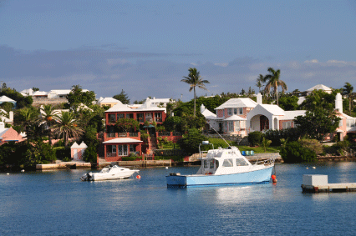
- Officers Meeting

- Famous Homes & Hideaway Boat Tour
This tour will give you a wealth of well-researched historical facts as well as lots of humorous personal stories about the island. We will get a sneak peek at “Millionaire’s Row” one of Bermuda’s most exclusive neighborhoods. We will see the homes of the rich and famous such as movie stars Michael Douglas and Catherine Zeta-Jones; James Martin, pioneer of Texas
Instruments; playwright Eugene O’Neal, who daughter was
married to Charlie Chaplin; and illustrator William
Denslow, most famous for his work on the “Wizard of
Oz”. We will also learn about the island’s, past and
present, flora and fauna and wonderful marine life as
we gently cruise Bermuda’s exquisite turquoise blue waters.

- Golf Outing – Port Royal Golf Course (For those not going on the
- Famous Homes & Hideaway Boat Tour)
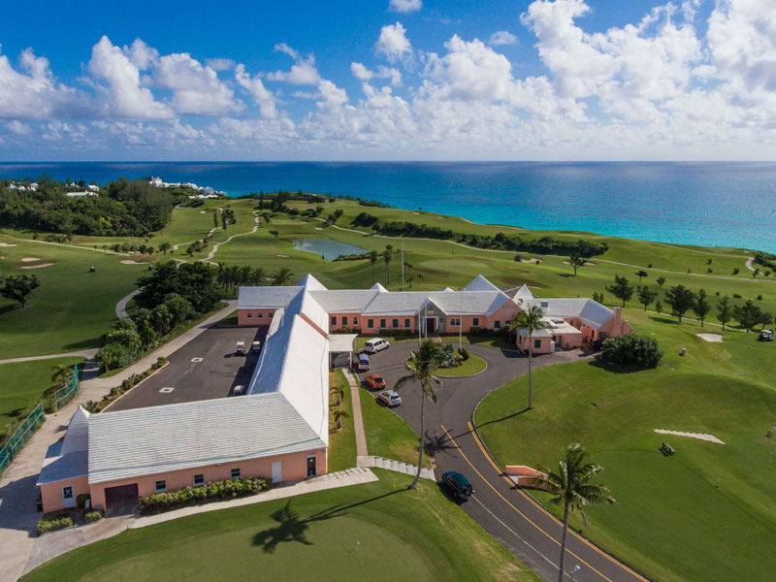

- Evening on Own
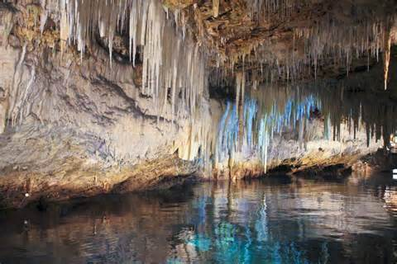
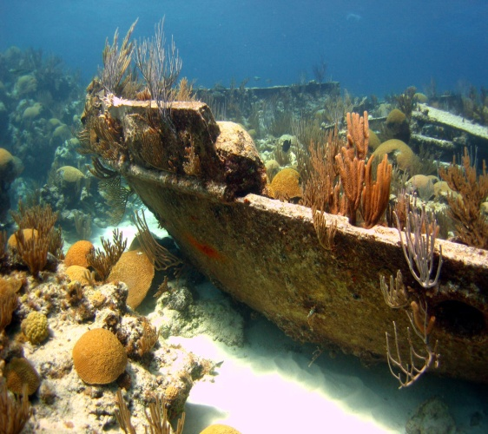
Tuesday, October 22, 2019
- Excursion to the Parish of St. Georges
- First stop tour of Crystal Caves
Bermuda’s Crystal Caves are a safely guided tour down into the depts 80 feet below the surface. We will view a spectacular undersea cavern with crystal clear water that raises and lowers with the daily tides.

- Walking Tour of St. Georges & The East End/Shopping
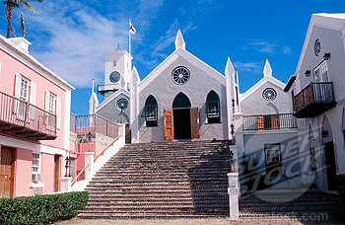

Settled in 1612, St. George’s is the oldest continuously occupied town of English origin in the New World. It provides a magical old-world walking tour experience to all who explore its winding lanes and entering buildings largely untouched by the passing centuries and is a great opportunity to learn about Bermuda’s culture, history and Heritage.

- Lunch at Wahoo Restaurant in St. Georges

- Return by bus to Fairmont with a stop in Hamilton for those who want to shop.

Note: Transportation to the hotel from Hamilton will be “on own”. The last complimentary ferry departs Hamilton at 5:15 pm. Those not making the 5:15 ferry can return via taxi. Taxi fare to the hotel from Hamilton is approximately $20 - $25.

- Dinner on Own
Wednesday, October 23, 2019
- Breakfast for Registered Attendees
- 9:30 – 12:00 pm IILA General Education Session
- Luncheon for Attendees
- 1:30 – 3:00 pm Annual General Meeting
- 3:00 – 4:00 New Officer Meeting
- 4:00 – Officers Rendezvous
- Remainder of the Day and Dinner on own

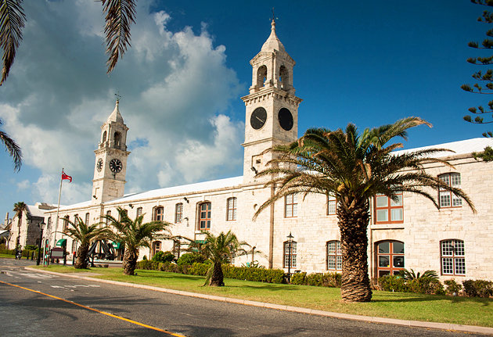
Thursday, October 24, 2019
- Excursion to the Royal Dockyards & West End
- Drive & Stop Tour
- Walking Tour of the Royal Naval Dockyard
This tour will provide some of Bermuda’s most beautiful views combined with History and Heritage. We will depart the hotel and enjoy a tour through Southampton and Sandy’s Parish. We will cross over Somerset Drawbridge, the smallest functioning drawbridge in the world. We then continue on to the Royal Naval Dockyard, situated on the tail of the island on Ireland Island North, which is now the center of some of Bermuda’s liveliest tourist attractions including restaurants, Dockyard glassworks, Bermuda Rum Cake Factory, gift shops
and arts and crafts. The Bermuda Maritime Museum, housed within eight historic buildings, including old munitions warehouses and the Commissioner’s House is a variety of exhibits on Bermuda’s rich maritime history.

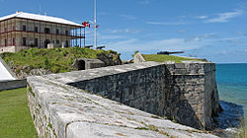
- Visit to the National Museum of Bermuda
After the English colonies in North America had established their independence, Bermuda was developed as a major British naval base to control the sea lanes to North America. The Dockyard construction started in 1809 and continued for a century. Buildings of the Keep were constructed using the local limestone. Work was done initially by slaves, later by convicts, prisoners, and laborers imported from the West Indies. The dockyard closed in the late fifties, and buildings started to fall into disrepair. In 1974 the Bermuda Maritime Museum took over the site of the Keep and restoration began. The Museum changed its name in 2009 to reflect its broader national focus. This name change was formalized in 2013 after an amendment was made to the Museum’s Act.

- Lunch at Frog & Onion Pub

- Depart back to the Fairmont Hotel.
Note: Those who wish to go back to Hamilton for more shopping can transfer via the public ferry. Transportation to the hotel from Hamilton will be “on own”. The last complimentary ferry departs Hamilton at 5:15 pm. Those not making the 5:15 ferry can return via taxi. Taxi fare to the hotel from Hamilton is approximately $20 - $25.

- 6:00 – 7:00 pm Cocktail Reception
- 7:00 – 10:00 pm Banquet Dinner & Presentations

Friday, October 25, 2019
- Departure

