2019 IILA Conference & Annual General Meeting
October 20 – 24, 2019
Bermuda

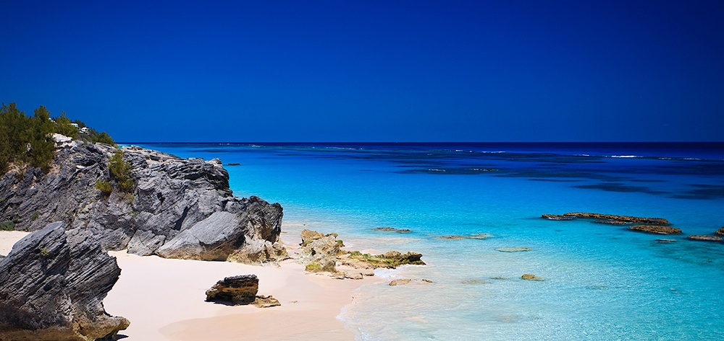
After you have paid by PayPal or Wire at www.iila.com for the below Registration event(s), please fill out and email this form to: tmoss@tenco.com.
REGISTRATION FORM
The Following person(s) will be in attendance
Passport Name: ________________________________________________________________________
Passport Number: ______________________________________________________________________
Nationality: ___________________________________________________________________________
________ Member ________ Spouse ________ Guest
The person above is attending the following:
______ Pre-Conference New York ______ Conference, Bermuda _______Golf, Bermuda
♦ ♦ ♦ ♦ ♦ ♦ ♦ ♦ ♦ ♦ ♦ ♦ ♦ ♦ ♦ ♦ ♦ ♦ ♦ ♦ ♦ ♦ ♦ ♦ ♦ ♦ ♦ ♦ ♦ ♦ ♦ ♦ ♦ ♦ ♦ ♦ ♦ ♦ ♦ ♦

Passport Name: ________________________________________________________________________
Passport Number: ______________________________________________________________________
Nationality: ___________________________________________________________________________
________ Member ________ Spouse ________ Guest
The person above is attending the following:
______ Pre-Conference New York ______ Conference, Bermuda _______Golf, Bermuda
♦ ♦ ♦ ♦ ♦ ♦ ♦ ♦ ♦ ♦ ♦ ♦ ♦ ♦ ♦ ♦ ♦ ♦ ♦ ♦ ♦ ♦ ♦ ♦ ♦ ♦ ♦ ♦ ♦ ♦ ♦ ♦ ♦ ♦ ♦ ♦ ♦ ♦ ♦ ♦

Passport Name: ________________________________________________________________________
Passport Number: ______________________________________________________________________
Nationality: ___________________________________________________________________________
________ Member ________ Spouse ________ Guest
The person above is attending the following:
______ Pre-Conference New York ______ Conference, Bermuda _______Golf, Bermuda
♦ ♦ ♦ ♦ ♦ ♦ ♦ ♦ ♦ ♦ ♦ ♦ ♦ ♦ ♦ ♦ ♦ ♦ ♦ ♦ ♦ ♦ ♦ ♦ ♦ ♦ ♦ ♦ ♦ ♦ ♦ ♦ ♦ ♦ ♦ ♦ ♦ ♦ ♦ ♦

Passport Name: ________________________________________________________________________
Passport Number: ______________________________________________________________________
Nationality: ___________________________________________________________________________
________ Member ________ Spouse ________ Guest
The person above is attending the following:
______ Pre-Conference New York ______ Conference, Bermuda _______Golf, Bermuda
♦ ♦ ♦ ♦ ♦ ♦ ♦ ♦ ♦ ♦ ♦ ♦ ♦ ♦ ♦ ♦ ♦ ♦ ♦ ♦ ♦ ♦ ♦ ♦ ♦ ♦ ♦ ♦ ♦ ♦ ♦ ♦ ♦ ♦ ♦ ♦ ♦ ♦ ♦ ♦

Passport Name: ________________________________________________________________________
Passport Number: ______________________________________________________________________
Nationality: ___________________________________________________________________________
________ Member ________ Spouse ________ Guest
The person above is attending the following:
______ Pre-Conference New York ______ Conference, Bermuda _______Golf, Bermuda

6.18.19.7:00

