THOMAS E. ERHARDT
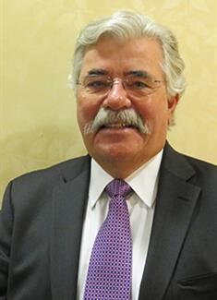 ERHARDT ADJUSTMENT COMPANY, INC.
1111 Broadhollow Road
Farmingdale, NY 11735
631-465-0877
terhardt@eacadjust.com
www.eacadjust.com
______________________________________________________________________

EDUCATION
Adelphi University- B.A.- Business Administration
Nassau Community College- A.A.S.
Vale Tech-Building Building Damage Estimating
Completion of IIA Property Loss Adjusting
Participated in Annual Seminars of Property Loss Research Bureau - Chicago, IL
Various Industry Seminars
CIU-Certified Independent Appraiser
CIA-Certified Independent Umpire

EXPERIENCE
Erhardt Adjustment Company, Inc. – Farmingdale, New York
President- 1988- Present

Cardinal Claim Service, Inc.
1973-1988

ADJUSTER LICENSES
New York

ORGANIZATIONS
National Association of Independent Adjusters- Eastern Regional VP 2008-2010
New York Association of Independent Insurance Adjusters-Past President 1994-95
International Institute of Loss Adjusters-1st Vice-President 2018-2020
The Loss Executive Association-Associate Member
Eagle International Associates

Personal and Professional references furnished upon request

