2019 IILA Conference & Annual General Meeting
October 20 – 24, 2019
Bermuda

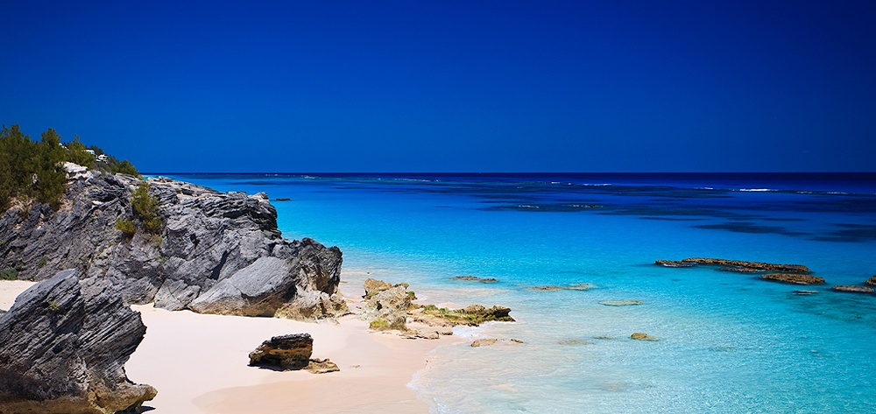
BERMUDA IS ANOTHER WORLD…
700 Miles at Sea, and the Way the People Greet You Is Like a Friendly Melody!

The Fairmont Southampton Hotel ♦ Southampton Bermuda

The host site for the IILA Annual General Meeting will be the five-star hotel - the Fairmont Southampton Hotel located in the Southampton Parish in Bermuda. The hotel has recently been renovated and has its own signature Par 3 – 18-hole golf course as well as having its own beach/pool facility and ferry service to Hamilton - Bermuda's capital city.

Our meeting planner (The Beaumont Group) has negotiated extremely favorable room rates of $199.00 per night (excluding taxes) for standard accommodations. In addition, for those who want to upgrade themselves, when you click on the reservation link, there are other room categories available at varying rates based on room categories available.

The itinerary will feature tours of the island's historical sections along with a sailing cruise around the island and golfing at the Port Royal Golf Course - one of the signature golf courses on the island.

We anticipate having a first-class education program which will feature dignitaries from the island's Ministry of Finance and Insurance, along with feature presentations on cyber liability and other current topics.

The meeting will conclude with a gala banquet before departure from this insurance centric island paradise.

The IILA registration cost for the conference will be $1,900.00 per person. For those of you playing golf at the Port Royal Golf Course, there is a separate fee is $165 per person and includes: transportation; green fees and carts.
Looking forward to seeing one and all in Bermuda in October and should you have any questions concerning the meeting, please do not hesitate to contact me.

Sincerely yours,
C.J. Reilly, Jr.
Charles J. Reilly, Jr., CPCU, RPA, CAU
2019 IILA Convention Chairman

