2019 IILA Conference & Annual General Meeting
October 16 – 19, 2019

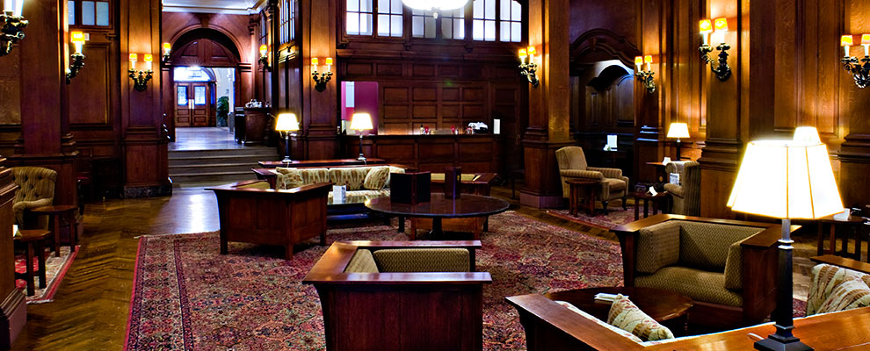

PRE-CONFERENCE TOUR

The Downtown Association ♦ 60 Pine Street ♦ New York, New York 10005
October 16 – 19, 2019
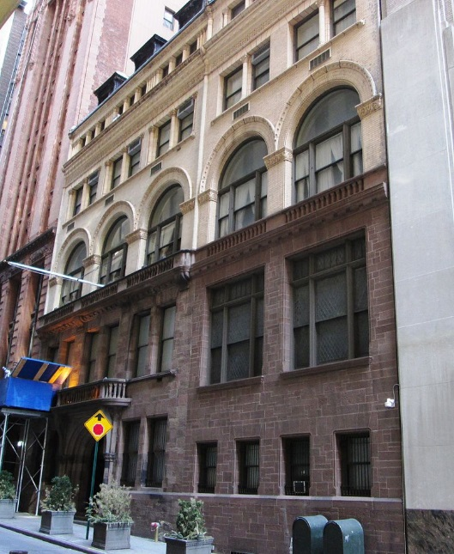
The host site for the Pre-Conference Tour will be The Downtown Association located at 60 Pine Street New York, New York. This venue is one of the oldest private clubs in the City of New York, which was founded in 1860. This venue will be the launching point for our group and it features newly remodeled guest rooms - the largest by far in Lower Manhattan, with a group rate of $275.00 per night ($60.00 less than the member rate!). The arrival date will be Wednesday, October 16, 2019.

The itinerary will consist of several walking tours which will highlight historical lower Manhattan. It will feature Federal Hall, Trinity Church, the Canyons of Wall Street, Battery Park, The World Trade Center, museums and local watering holes. It will culminate with a dinner and Broadway show.

The pricing will be $375.00 US Dollars per person - which will cover the guided tour sections and museum fees- and does not include food and beverage which will be on one's own. Once the attendees have been finalized - a group dinner and Broadway show will be booked, which will be added to the pre-conference tour pricing.

Reservations can be made by contacting Mr. A. Martinez, the Front Office Manager by telephone 212-422-1982 or via email - reservations@thedta.com. Please mention the International Institute of Loss Adjusters Group (or Mr. Reilly's group)

Departure for Bermuda will be on Sunday October 20, 2019. The airlines who service Bermuda are as follows;

- Air Canada
- American Airlines
- British Airways
- Delta Airlines
- Jet Blue Airways
- United Airlines

Most regular service is through either JFK International Airport (New York) or Newark Liberty International Airport (New Jersey). Airfares from the New York Metropolitan area to Bermuda, round-trip, range from $350.00 - $600.00 US Dollars.

Looking forward to seeing one and all in New York and should you have any questions concerning this tour, please do not hesitate to contact me.

Sincerely yours,
C.J. Reilly, Jr.
Charles J. Reilly, Jr., CPCU, RPA, CAU
2109 IILA Pre-Conference Chairman

